**Simple LabVIEW Projects**

Some LabVIEW Project and content I did until 14 July

**1.User Login Interface**

This Project has two stages. Firstly page 1, user types “User Name” and “Password” for login.

Secondly Page 2, the user sums the two numbers and sees the result in the addition box. At the same time, these transactions are written in a excel file. File path : ProjectFile/Data Log/Data_ .

I learned to use block diagram, case structures, for loop, while loop, some comparison functions , some numeric functions, some array functions, etc.

**2.Tire Balancing**

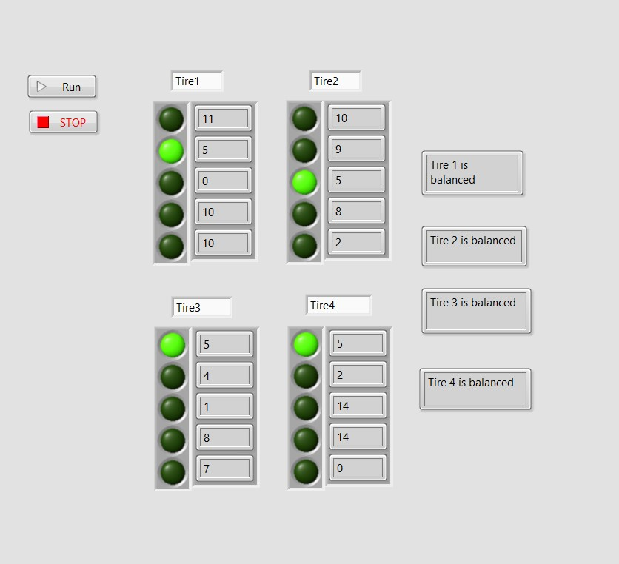

The aim of this project, generate random number and find the number five. In the array, the tire that finds the number five stops working. The process continues until all tire are founds.

I learned to use strings,random numbers, boolean and buttons.

**3.Security System**

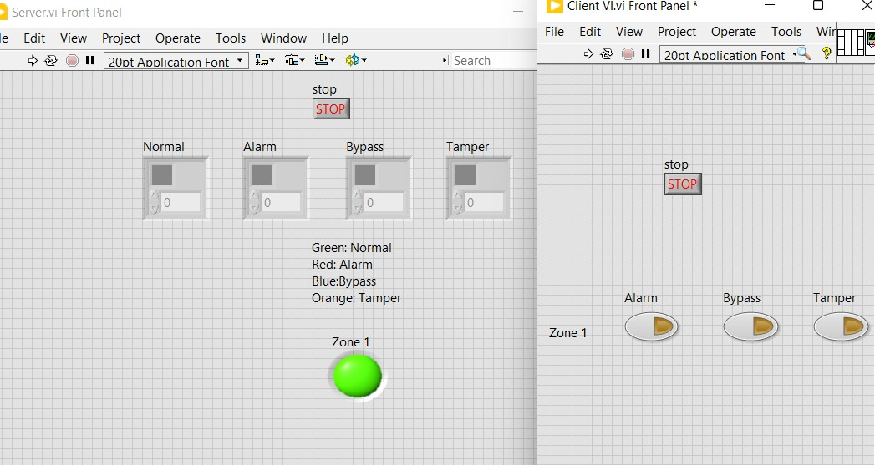

There are two differents VIs in this Project. First VI is the Client VI, this VI has 3 different buttons. These buttons are Alarm, Bypass, Tamper. When a random key is pressed, Server VI led lights up. But this Project not working because ı don’t have a TCP/IP Library.

**

There are 6 different settings for drawing shapes in the Project. These setting are Amplitude, Phase and Frequency. If you increase the values while working it will keep drawing continuously

**5.User Defined Boxes**

This Project is just about shapes direction. There are some settings on the back, you can change the direction of the shape by changing them.

**6. EMG Signal Processing**

User select a signal file. User can change highpass and lowpass and select any menu items.